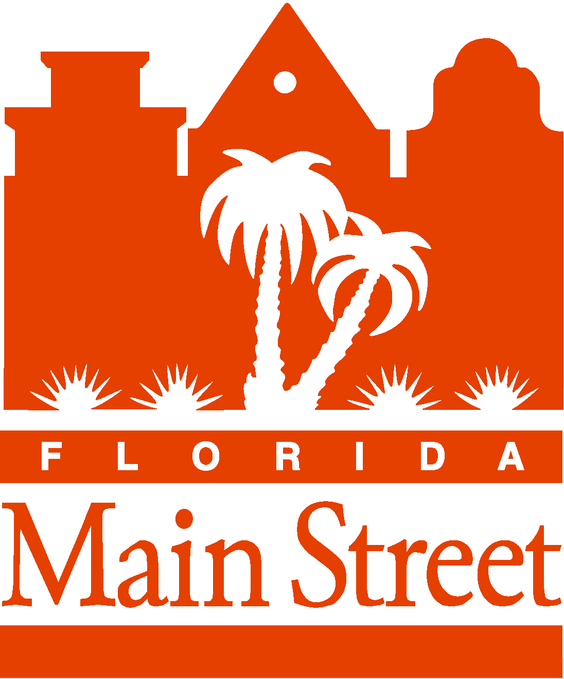

Secretary of State's

Florida Main Street Awards Program

Purpose

In order to encourage and acknowledge activities which advance the mission of the Florida Main Street program for revitalization and preservation in Florida communities, the Division of Historical Resources, Florida Department of State, has developed the annual Secretary of State's Florida Main Street Awards Program.

Procedures

Each year, the Division of Historical Resources will form an ad hoc committee to review nominations and recommend to the Secretary of State those individuals, businesses, organizations and agencies considered especially worthy of state-wide recognition. Awards may not necessarily be given in each category every year. However, multiple awards may be given in each category.

The Ad Hoc Florida Main Street Awards Committee is composed of five members – the Program Coordinator, the Division Architect assigned to the program, and three local Program Managers appointed by the Division Director.

CRITERIA FOR SUBMISSION:
- Any active local Main Street program may submit one nomination per category, per year, but each program will be limited to five total nominations.

- Eligible projects must have been completed within the past 12 months.
- To be eligible for awards, communities must be active local programs as defined in 1A-36, Florida Administrative Code (i.e., programs that have been designated by the Secretary of State and employ a full-time manager (or part-time manager if the city has a population of less than 5,000), carry out a program consistent with the Main Street Approach, submit quarterly reports, attend statewide meetings, and participate in the network of Florida Main Street communities). Attached pdf is Section 1A-36.010 in its entirety.

- Communities are not eligible for Secretary of State Award nomination until up-to-date reports are completed and submitted.

- Award nominations that are received after the nomination deadline shall be automatically rejected, and shall be returned to the nominator.

Nominations will be reviewed for completeness by Division of Historical Resources staff and evaluated by the Ad Hoc Florida Main Street Awards Committee based on the criteria for the individual award categories and the degree to which the nominees have made a positive impact on local Florida Main Street efforts or on the statewide program. The Committee will recommend nominees to the Secretary of State who will confer the awards.

Nominations must be on the enclosed nomination form and must include all indicated supporting material, including at least two high resolution digital photos (jpg format preferred) suitable to assist with the evaluation of the project and for use in the conference program and at the annual awards presentation. All nominations must be electronically submitted to the office of the Bureau of Historic Preservation on or before 5:00 P.M. on the date of the annual nomination deadline.

ALL NOMINATING MATERIALS WILL BECOME THE PROPERTY OF
THE DIVISION OF HISTORICAL RESOURCES.

All nominations must be electronically submitted to the Bureau of Historic Preservation, Florida Main Street office
no later than 7:00 PM EDT on Saturday, April 8, 2017

Award Categories

Organization

1. Outstanding Local Florida Main Street Program Supporter
This award may be given to an individual, business, organization or agency that has been active in a local Florida Main Street organization and has made a commitment of time and resources to downtown revitalization that has resulted in exceptional positive results. Please submit detailed information about the nominee's background and accomplishments, as well as two high resolution digital photos.

2. Outstanding Florida Main Street Fundraising or Membership Development Effort
This award may be given to a local Florida Main Street program which has displayed exceptional creativity in securing funds or building its membership. The nomination may focus on a single fundraising event, a fundraising campaign or a membership development strategy. Please submit detailed information, copies of materials developed to support the effort and two high resolution digital photos.

3. Outstanding Florida Main Street Private-Public Partnership
This award may be given to a local government entity or agency which has demonstrated a high degree of cooperation with a local Florida Main Street program in its downtown revitalization efforts. Please describe fully how the public and private sectors have worked together on a particular project or on an on-going basis, include names of participants and attach two high resolution digital photos.

4. Outstanding Supporter of the Statewide Florida Main Street Program
An award may be given to a local Florida Main Street Manager, staff member of a statewide organization or agency or other individual, business, organization or agency which has made a significant contribution to the statewide Florida Main Street program. Please provide detailed information on the nominee's background and contributions and attach two high resolution digital photos.

Design

1. Outstanding Florida Main Street Rehabilitation Project
Individuals, businesses, organizations or agencies, which have completed an outstanding historic rehabilitation project are eligible for this award. The project must be located in a local Florida Main Street program area and must include exterior rehabilitation work, but may include both interior and exterior renovation. Please be sure to submit a brief narrative describing the project work, before and after separately attached high resolution digital photos, both exterior and interior, a description of the building's use, and the names of the owner, architect and contractor. (Note: "The Secretary of the Interior's Standards for Rehabilitation and Guidelines for Rehabilitating Historic Buildings" will guide Committee evaluation of these projects.)

2. Outstanding Florida Main Street Public Improvement
This award may be given to a Florida Main Street community's city government, agency, or other organization that has designed and implemented attractive, effective and appropriate public improvements within its local program area. Be sure to include a brief narrative describing the project work, two high resolution digital photos and information on the participants in the project: contracting party, designer, engineer, contractor, etc.

3. Outstanding Florida Main Street New Construction Project
This award may be granted to an individual, business, organization or agency that has completed a new building or development project within a local Florida Main Street program area that is notable for quality design that contributes to and is compatible with the surrounding physical environment. Be sure to include a brief narrative description of the project work, two high resolution digital photos, information on the building's use, and the names of the owner, architect and contractor.

4. Outstanding Florida Main Street Sign/Display Project
This award may be given to the individual, business, organization or agency that has completed a new or improved sign or merchandising display project within the local Florida Main Street program area. Be sure to include a brief narrative description of the project work, a two high resolution digital photos and information on the project, owner, contractor and designer.

Promotion

1. Outstanding Florida Main Street Special Event
This award may be given to a local Florida Main Street program that has conducted an exceptionally creative and effective special event (other than a retail sales event) in the local program area. Be sure to include two high resolution digital photos and information on theme, extent of participation, attendance and budget.

2. Outstanding Florida Main Street Image Campaign or Promotional Materials
This award may be given to a local Florida Main Street program that has developed an exceptionally creative and effective image campaign or promotional material. Nominees may have developed: slogans, advertising campaigns, newsletters, brochures, posters, videos, etc. Copies of materials and two high resolution digital photos must be included.

3. Outstanding Florida Main Street Retail Sales Promotion
This award may be given to a local Florida Main Street program that has conducted an innovative and effective retail sales promotion. Promotions can include: joint advertising, cross promoting by compatible merchants and special sales geared toward targeted customers. Complete information, copies of printed materials and two high resolution digital photos must be included.

Economic Restructuring

1. Outstanding Florida Main Street Economic Restructuring Program or Project
This award may be given to a local Florida Main Street program or individual, business, agency or organization which has developed an exceptionally innovative and effective approach to assisting existing businesses or recruiting new businesses into a local Florida Main Street program area. Nominees may have conducted: workshops to promote better business practices; market analyses to identify new customers or businesses; financial incentive programs; or recruiting drives for new businesses; etc. A complete description of the project or program, including participants, materials and two high resolution digital photos must be included.

2. Florida Main Street Business of the Year
A local Florida Main Street program area merchant who has made an exceptional contribution to downtown revitalization may be granted this award. The nominee may have played a leadership role in a local Florida Main Street organization, made a substantial investment in a downtown project or taken other positive action that supported a local Florida Main Street program or the statewide program.
Please submit detailed information on the nominee's background and accomplishments, as well as two high resolution digital photos

Secretary of State's Florida Main Street
Award Nomination Form
Submit following pages only

- AWARD CATEGORY:_________________________________________________
- Main Street Organization: ______________________________________________
- Nominated By:
Name & Title: _______________________________________________________
- Email address: ___________________________ 3. Phone __________________
- Address: ___________________________________________________________
Please check appropriate Award Category (only one category per form). Please see Award Categories for detailed information and criteria.

ORGANIZATION
- Outstanding Local Program Supporter
Name of Nominee ____________________________________
- Outstanding Fundraising or Membership Development Effort
Name of Project _____________________________________
- Outstanding Public-Private Partnership
Names of Partnership__________________________________
- Outstanding Supporter of the Statewide Florida Main Street Program Name of Nominee ____________________________________

DESIGN
- Outstanding Rehabilitation Project
Name of Project _____________________________________
- Outstanding Public Improvement
Name of Project _____________________________________
- Outstanding New Construction Project
Name of Project _____________________________________
- Outstanding Sign/Display Project
Name of Project _____________________________________

PROMOTION
- Outstanding Special Event
Name of Event _____________________________________
- Outstanding Image Campaign or Promotional Materials
Name of Campaign ___________________________________
- Outstanding Retails Sales Promotion
Name of Promotion____________________________________

ECONOMIC RESTRUCTURING
- Outstanding Economic Restructuring Program or Project
Name of Project _____________________________________
- Business of the Year
Name of Business ____________________________________

- Brief description of individual, business, organization or agency accomplishment(s) recognized by this nomination (please limit to 80 words).

(Attach additional pages, if needed. Please limit submission to two (2) pages)

Nominator’s Signature: _______________________________ Date:

All nominations must be electronically submitted to the Florida Main Street office by Saturday, April 8, 2017. If you need additional information, contact Katherina Paliwoda at katherina.paliwoda@dos.myflorida.com or call 850.245.6346.

Florida Main Street
Bureau of Historic Preservation
R.A. Gray Building, 4th Floor
500 South Bronough Street
Tallahassee, FL 32399-0250
floridamainstreet@dos.myflorida.com

