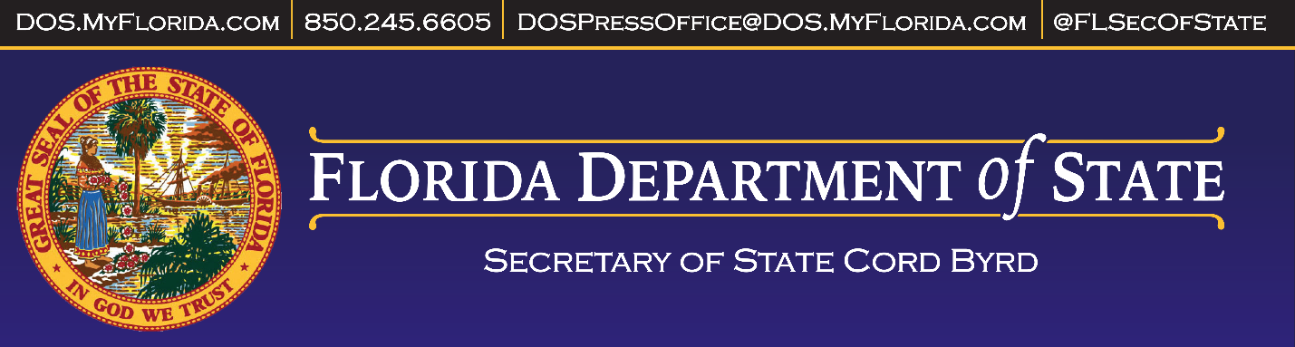

|  |  |
| --- | --- |
| **FOR IMMEDIATE RELEASE** | **CONTACT:** Mark Ard |
| March 21, 2023 | 850-245-6529 |
|  | Mark.Ard@DOS.MyFlorida.com |

**MEDIA ADVISORY: Certification of** **Special Primary Election for State Representative, District 24**

**TALLAHASSEE, Fla. —** The Florida Department of State's Division of Elections announces the following meeting of the Elections Canvassing Commission.

**Date: Tuesday, March, 2023**

**Time: 9:00 a.m. (Eastern Time)**

**Location: Cabinet Meeting Room, LL03, The Capitol, Tallahassee, Florida**

**Subject: Certification of the 2023 Special Primary Election for State Representative, District 24 results.**

**Participants: Members of Florida’s Elections Canvassing Commission will include Governor Ron DeSantis, Attorney General Ashley Moody, Chief Financial Officer Jimmy Patronis. All members will be participating by phone.**

###