Standards for

Determining

Voter Intent

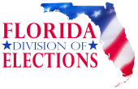

DS-DE 420 (eff XX-XX) R1S – 2.027, Fla. Admin. Code

Contents

Overview 3

Section A. General applicability 3

Section B. Digital scan voting system 4

Section C. Review for consistency 4

Section D. Intent based on consistency of marks and/or words 7

1. Circled or underlined vote target area 7

2. Circled or underlined name or choice 7

3. Circled or underlined party abbreviation 8

4. Marks – X, check, cross, plus sign, asterisk, star 8

5. Marks – diagonal, horizontal, or vertical lines 9

6. Additional marks or clarification 10

7. Strikethroughs 11

8. Mark outside the vote target 11

9. Words 12

Section E. Determination of definite choice for write-in votes 13

1. Last name of candidate or joint candidate 13

2. Filled in vote target and write-in name 13

3. Name written in 14

4. Abbreviation, misspelling, or variation 14

Section F. Overvote(s) 15

Section G. Undervote(s) 17

Section H. When Consistency is Unnecessary 18

1. Partially marked vote target 18

2. Marginal Marks 18

3. Marks with words 19

4. Water Damage 20

5. Torn or Missing Races 20

|  |
| --- |
| Overview |

1. When a voter has not properly marked his or her choices by filling in the vote target (e.g., oval) completely, the voter has not followed the General Rule. See 1S-2.032
2. When the voter does not follow the General Rule, the ballot card must be reviewed to determine whether there is a clear indication on the ballot card that the voter has made a definite choice.
3. First, examine the ballot card for consistency.
4. If a voter does not follow the General Rule and there is only one race on the ballot card, consistency is undeterminable and the race cannot be counted unless the race is marked as in Section H.
5. A choice left blank is always an invalid vote. A voter’s failure to positively indicate voter intent through some type of mark is not a clear indication that the voter has made a definite choice. See p. 10-11 “**7. Strikethroughs**”

|  |
| --- |
| Section A. General applicability |

1. The standards in this rule apply to determine whether the voter has made a clear indication on the ballot card showing a definite choice for a candidate, ballot measure, or judicial retention choice.

2. References to the “General Rule” refer to the voter following the instructions on the ballot or machine to properly mark his or her choices by filling in the vote target completely. See 1S-2.032, F.A.C.

3. Every overvote, undervote, blank vote, ambiguous mark, and write-in vote in the races or measures subject to a manual recount must be reviewed in accordance with these standards.

4. If a voting system initially rejects a ballot card due to one or more ambiguous marks, one or more races with an overvote, or no votes on an entire ballot card, the entire ballot card shall be reviewed for clear indication that the voter has made a definite choice and possible duplication.

5. The standards in this rule apply in all instances where the voter did not follow the General Rule for marking a ballot card so that a review of the voter’s markings is required to determine whether there is a clear indication that the voter has made a definite choice in a race. A vote shall not count for a candidate, issue choice, or judicial retention choice in a contest unless determined to be a valid vote pursuant to the standards set forth in this rule. The rule does not contemplate all potential types of marks made by a voter.

6. If a voter does not mark a choice for candidate, judicial retention or ballot measure in a race, the valid votes for other candidates or issues on the same ballot card shall still be counted.

7. If a voter does not follow the General Rule and there is only one race on the ballot card, consistency is undeterminable, and the race cannot be counted unless the race is marked as in Section H.

|  |
| --- |
| Section B. Digital scan voting system |

**1.** A vote cast on the voting system is valid for a particular candidate (printed or qualified write-in), ballot measure, write-in, or judicial retention choice when the voter marks the ballot card by following the General Rule.

**2.** A vote cast on the voting system is valid for a qualified write-in candidate when the voter marks the ballot card and writes in the name of a candidate in the designated write-in space or next to the write-in candidate’s name. If the voter does not follow the General Rule, then the write-in votes must be marked consistently.

|  |
| --- |
| Section C. Review for consistency |

**1.** The canvassing board should first review the entire ballot card for consistency in the way the voter marked the races. A ballot card consists of two sides (front and back). A ballot may consist of multiple ballot cards. Consistency is necessary to determine whether the voter has made a definite choice when the voter does not follow the General Rule.

**2.**  If the voter marks are consistent within a section of the ballot card, as in example below, apply section D to determine whether the voter has made a definite choice. The following are examples of valid votes after review for consistency:

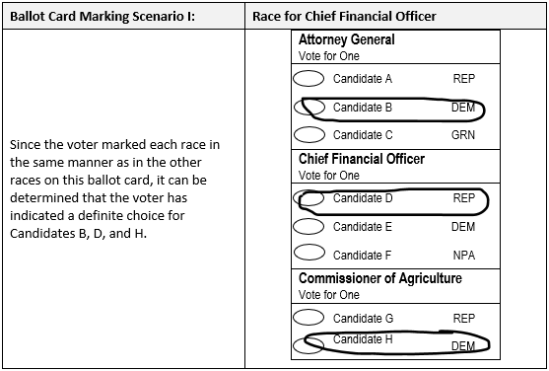

**3.** If the voter marks are inconsistent within a section of the ballot card, as in the example below, do not apply section D. The following are examples of valid and invalid votes after review for consistency:

|  |
| --- |
| Section D. Intent based on consistency of marks and/or words |

When a voter marks his or her ballot card in a manner other than by following the General Rule set forth in Section A.2., but there is consistency with the type of mark or word(s) used, the following examples illustrate valid or invalid votes.

## 1. Circled or underlined vote target area

The voter consistently circles or consistently underlines the vote target area next to a candidate’s name, ballot measure, or judicial retention choice.

~~

## 2. Circled or underlined name or choice

The voter consistently circles or consistently underlines candidate’s name, ballot measure, or judicial retention choice.

## 3. Circled or underlined party abbreviation

The voter consistently circles or consistently underlines the party abbreviation associated with a candidate’s name.

## 4. Marks – X, check, cross, plus sign, asterisk, star

The voter consistently uses “X,” consistently uses check marks, consistently uses crosses, consistently uses plus signs, consistently uses asterisks or consistently uses stars, and these are contained in a vote target. However, the marking must not enter another vote target. Regardless of consistency, when a mark enters more than one vote target, it is an overvote and it cannot be determined whether the voter has made a definite choice, making it an invalid vote.

## 5. Marks – diagonal, horizontal, or vertical lines

The voter draws a diagonal, horizontal, or vertical line, any portion of which intersects two points on the vote target and which does not intersect another vote target. If it is a horizontal line, the line must not strike through the name of the candidate. If the line crosses two or more vote targets, the vote is invalid.

## 6. Additional marks or clarification

The voter marks more than the allowable number of choices in a race but further clarifies a definite choice for a particular candidate, ballot measure, or judicial retention choice by placing an additional mark or marks showing support solely for that candidate, ballot measure, or judicial retention choice.

## 7. Strikethroughs

The voter strikes through all the choices for candidates and leaves the write-in candidate space blank.

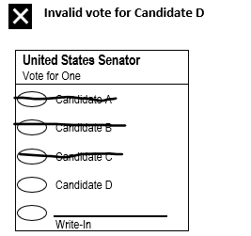

## 8. Mark outside the vote target

If a voter marks outside the vote target such that the voter’s choice cannot be determined, it shall be considered an invalid vote.

## 9. Words

The voter writes words such as “Vote for [candidate’s name],” “Count this vote” or “Vote no on amendment or referendum,” or “I want this one,” provided there are no other markings in the race that would constitute a valid vote for a different candidate, ballot measure, or judicial retention choice pursuant to rule. If there are other markings, **Section F. Overvotes** shall control.

|  |
| --- |
| Section E. Determination of definite choice for write-in votes |

## 1. Last name of candidate or joint candidate

A voter is determined to have made a definite choice for a write-in vote for the joint office of President/Vice-President if the voter writes in either the last name of the qualified write-in candidate for President or Vice-President or the last name of a candidate for President or the last name of the candidate for Vice-President who is named on the ballot card in that race. This standard similarly applies to constitute a valid write-in vote for the joint office of Governor/Lieutenant Governor. If the voter writes in the name of a candidate on the ballot card, review the ballot card for consistency following Section C.

## 2. Filled in vote target and write-in name

A voter is determined to have made a definite choice for a named candidate if the voter indicates a vote for a candidate named on the ballot card and writes-in the same candidate’s name in the blank ‘write-in’ space.

## 3. Name written in

A voter is determined to have made a definite choice for a candidate if the voter writes in the name of a qualified write-in candidate or a candidate listed on the ballot card in the race, whether the vote target designating the selection of a write-in candidate has been marked or not marked. However, if the voter writes in the name of a candidate who is named on the ballot card in that race, review the ballot card for consistency following Section C.

## 4. Abbreviation, misspelling, or variation

A voter is determined to have made a definite choice even if a voter abbreviates, misspells, uses only the first or last name, or varies the form of the name of a candidate in the write-in candidate space, if the name can be clearly attributed to only one candidate or qualified write in candidate. If a voter writes in a candidate on the ballot card, review the ballot card for consistency following Section C.

|  |
| --- |
| Section F. Overvote(s) |

**1.** If a voter marks more choices than there are positions or choices for that office or issue and there is no other clear indication on the ballot card that the voter has made a definite choice for an office or ballot measure , it shall be considered an overvote and none of the votes are valid for that race.

**2.** If a voter marks a choice for a candidate named on the ballot card and writes in any other name in the write-in candidate space, regardless of whether the write-in vote target is marked or the other name is a candidate on the ballot or qualified write-in candidate, there is no clear indication on the ballot card that the voter has made a definite choice for a candidate and the votes for that office are invalid.

**3.** If a voter marks the vote target area for a candidate named on the ballot card and marks the vote target area next to the write-in candidate space but does not indicate a name in that space, there is a clear indication that the voter made a definite choice and it is a valid for that candidate. As in the example above in 2., if any other name is written in the write-in space, it is an invalid vote.

|  |
| --- |
| Section G. Undervote(s) |

**1.** If a voter marks fewer candidates than there are positions to be elected for those offices, then the votes for all the marked candidates shall count. For example, if the voter is allowed to vote for five candidates in a special district election (“Vote for five”) and the voter marks two candidates, the votes for those two marked candidates shall count.

**2.** If a voter marks through a race in its entirety, even if candidates were chosen to be elected for those offices, there is no clear indication on the ballot card that the voter has made a definite choice for an office or ballot measure and the votes are invalid for that office or measure.

|  |
| --- |
| Section H. When Consistency is Unnecessary |

## 1. Partially marked vote target

The voter fills in more than half of the vote target designating a particular candidate, ballot measure, or judicial retention choice, and the voter followed the General Rule for the other votes, such a marking is consistent with the General Rule and valid.

### 

## 2. Marginal Marks

If a voter marks the vote target area in its entirety or marks more than half of the vote target area, it shall be considered a valid vote for that race even if there is a pen rest, stray, or hesitation mark~~s~~ on another vote target area. However, Section F. regarding overvotes shall control.

## 3. Marks with words

The voter marks two or more choices similarly and additionally writes in comments such as “not this,” “ignore this,” “don’t want,” or “wrong,” or “Vote for [candidate’s name]” such that voter’s definite choice is clearly indicated.

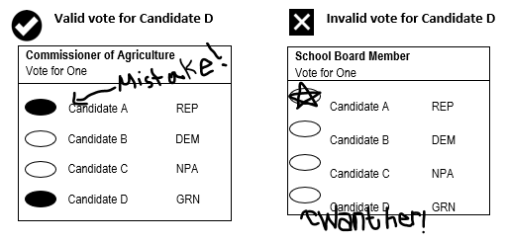

## 4. Water Damage

If a voter marks the vote target area consistent with the General Rule, but the physical condition of the ballot card has caused the ink to smear into another vote target, it shall be considered a valid vote for the original candidate if it can be determined which mark was the original mark made by the voter.

## 5. Torn or Missing Races

If the ballot card is missing entire races, either due to the physical condition of the ballot card or an incomplete fax from an overseas voter, the missing races shall be undervotes and no votes shall be recorded for any of the completely missing races.

If a portion of a race is physically present and there is a mark consistent with a vote, it shall be considered a valid vote for the marked candidate. However, if there is marking present in more than one vote target or candidate name, it shall be considered an overvote if the number of indicated votes exceeds the number allowed in the race.

