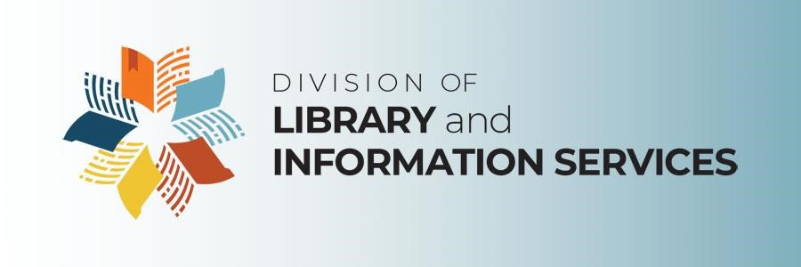

**Friends of the State Library and Archives of Florida Inc.**

**Special Committee on Division Event Support**

**Meeting Agenda**

**Thursday, November 1, 2024, 9:00 a.m. – 10:00 a.m., Eastern**

**This meeting is being held both in person and remotely via Zoom. Physical location: Room 307, R.A. Gray Building, 500 S. Bronough Street, Tallahassee, FL 32399. To attend virtually, register at:**

<https://dos-myflorida.zoom.us/meeting/register/tZctc-GoqzgqEtwFS3YRZbjYh7k2vKrhTSJa>

|  |
| --- |
|  |

Items printed in *RED ITALICS* indicate that a motion is required.

1. Call to order
2. Introduction of committee members, staff and guests
3. *Adoption of the November 1, 2024 meeting agenda*
4. Discussion on Division event support
5. Public comment
6. *Adjourn*

To request copies of meeting materials associated with this agenda, but not included herein, contact the Division of Library and Information Services at: dlisinfo@dos.myflorida.com or 850.245.6607.

Under Florida law, email addresses are public records. If you do not want your email address released in response to a public records request, do not send electronic mail to this entity. Instead, contact this office by phone or in writing.

In order to comply with Section 286.0114, *Florida Statutes*, the Division has established a [Public Comment Policy](http://dos.myflorida.com/library-archives/meetings-and-notices/public-comment-policy/) applicable to all committees, councils and work groups to allow members of the public an opportunity to address the group. A special time is set aside at all meetings for the purpose of receiving comments and suggestions from members of the public.