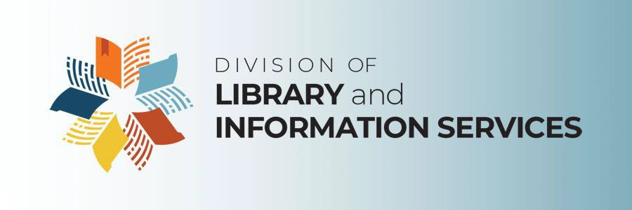

**2024 Annual Florida Public Library Directors Meeting, Final Agenda**  
All Times Eastern

|  |  |
| --- | --- |
| Wednesday, December 11 | |
| 8:30 – 9:00 a.m. | **Networking** |
| 9:00 – 9:30 a.m. | **Welcome**  Cord Byrd, Secretary of State (invited)  **Meeting Overview and Introductions**  **Reflecting on 2014 Vision for Florida Libraries**  Amy Johnson, Director |
| 9:30 – 10:15 a.m. | **Opening Story**  **Draw Your Future: How a Simple Picture**  **Changes Everything**  **Who’s Here**  Patti Dobrowolski, Founder  Up Your Creative Genius |
| 10:15 – 10:30 a.m. | **Break** |
| 10:30 a.m. – 12:15 p.m. | **Trends in Libraries**  **Current State of Libraries**  **Future State of Libraries** |
| 12:15 – 1:10 p.m. | **Lunch** |
| 1:10 – 1:20 p.m. | **Friends of the State Library and Archives**  **Partner Update**  Claire Dygert, President |
| 1:20 – 3:00 p.m. | **Future State of Libraries**, continued  **Three Bold Steps**  Patti Dobrowolski |
| 3:00– 3:15 p.m. | **Break** |
| 3:15 – 4:15 p.m. | **Three Bold Steps**, continued  **Three Bold Steps Rapid Roadmapping** |
| 4:15 – 4:30 p.m. | **Day Wrap-Up** |

|  |  |
| --- | --- |
| Thursday, December 12 |  |
| 8:30 – 9:00 a.m. | **Networking** |
| 9:00 – 9:45 a.m. | **Public Library Directors Conversation**  Amy Johnson |
| 9:45 – 10:30 a.m. | **Dementia Friendly Library Opportunities**  Nicolette Castagna, Florida State University  Amber Ladd, Department of Elder Affairs |
| 10:30 – 10:45 a.m. | **Break** |
| 10:45 – 11:15 a.m. | **Sunshine State Digital Network**  **Partner Update**  Keila Zayas Ruiz, Program Director  **Multitype Library Cooperatives and**  **2025 Voices for Libraries**  **Partner Update**  Brock Peoples, Executive Director, SEFLIN |

|  |  |
| --- | --- |
| 11:15 – 11:45 a.m. | **Your Library Has What?!?!** |
| 11:45 a.m. – 12:00 p.m. | **Meeting Wrap-Up** |
| 12:00 – 1:00 p.m. | **Lunch** |

For FY2024-25, 75% of total costs for Meetings of Florida Library Staff ($68,104) is supported with federal government funds (LSTA grant funds); 25% of this program ($22,996) is financed with state government money. The total budget of the project is $91,100.

The project is funded under the provisions of the Library Services and Technology Act from the Institute of Museum and Library Services. Florida’s LSTA program is administered by the Department of State’s Division of Library and Information Services.